12/01/2020

**DML Operation**

1. Change salary of employee 115 to 8000 if the existing salary is less than 6000.

Ans-update employees set salary=8000 where employee_id=115 and salary<6000;

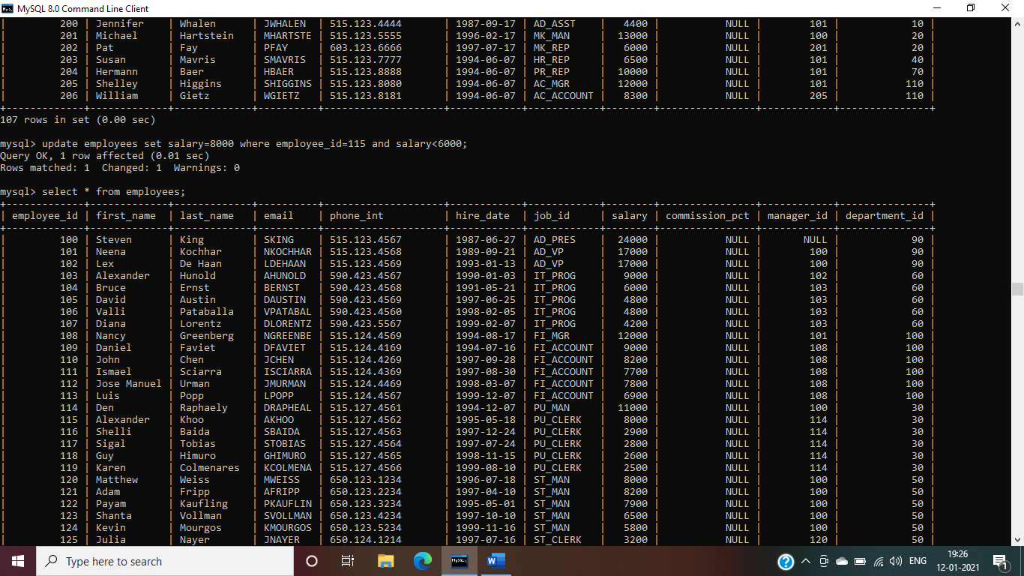

2. Insert a new employee into employees with all the required details.

Ans-

Drop foreign key-

alter table employees drop foreign key emp_job_fk;

Insert values-

insert into employees (employee_id,first_name,last_name,email,phone_int,hire_date,job_id,salary,department_id) values (99,'Aharna','Laha','aharna','100.100.1000','2020-12-29','p_trainee',10000,60);

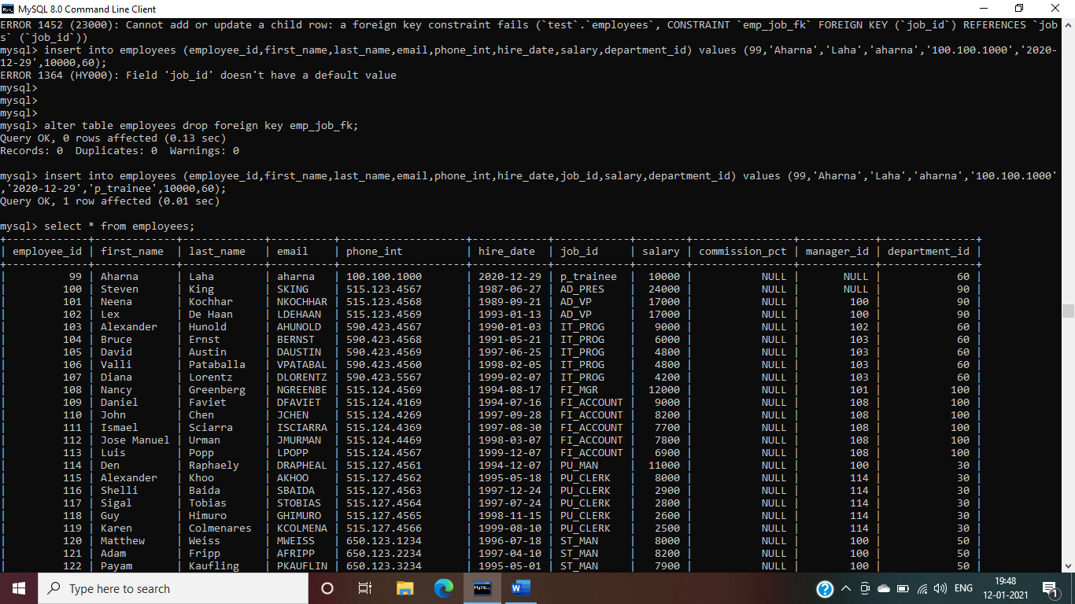

3. Delete department 20.

Ans-delete from departments where department_id=20;

4. Change job ID of employee 110 to IT_PROG if the employee belongs to department 10 and the existing job ID does not start with IT.

Ans-update employees set job_id= ‘IT_PROG’ where employee_id=110 and department_id=10 and not job_id like ’IT%’;

5. Insert a row into departments table with manager ID 120 and location ID in any location ID for city Tokyo.

Ans-insert into departments(99,’Games’,120,1200);

6. Display job title, employee ID, number of days between ending date and starting date for all jobs in department 30 from job history.

Ans-select employee_id,job_title,end_date-start_date as days from job_history natural join jobs where department_id=30;

**DDL Assignments with Constraints**

Table ---> Customer

custId, firstName,lastName,age,city, mobileNumber, dob

Add the Constraints

custId is Primary Key

firstName not null

age must be greater than 21

mobile must be unique

Ans-create table customer (custid int primary key,firstname varchar(10) not null,age int check(age>21),city varchar(10),mobile_number int unique,dob varchar(10));

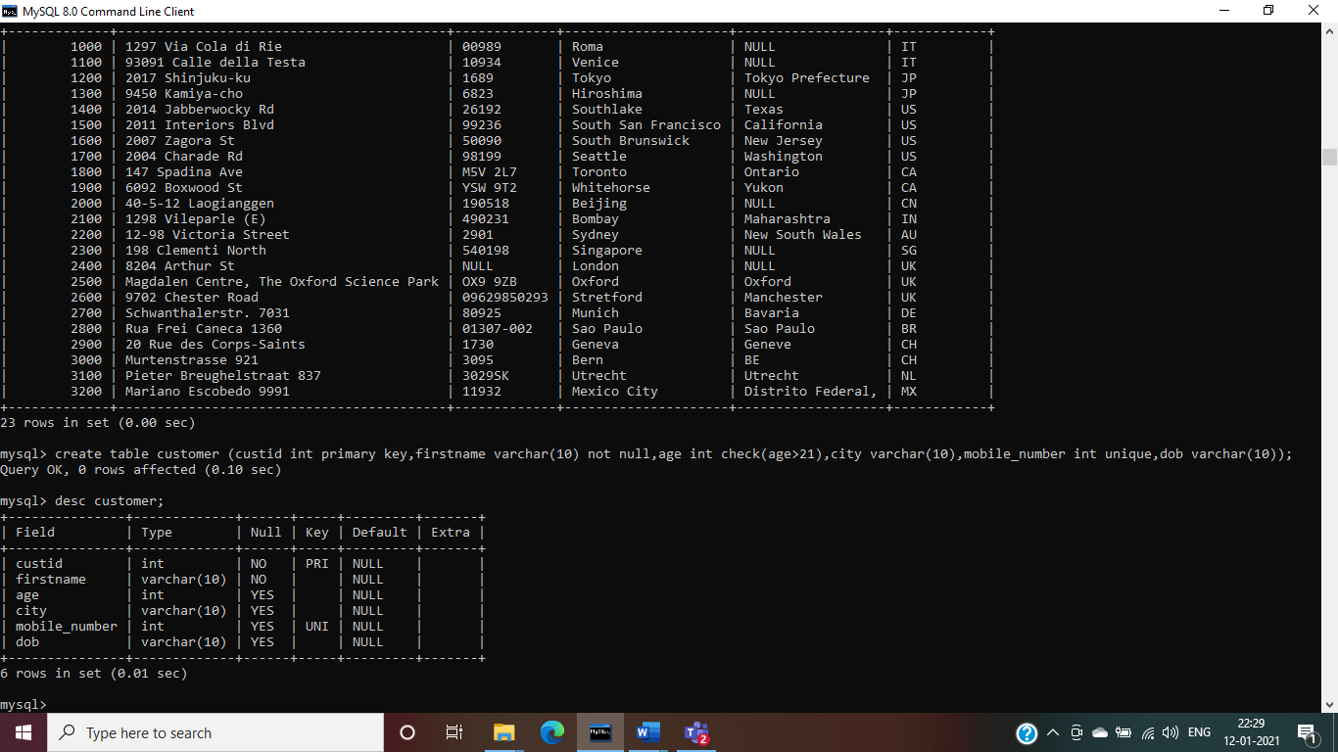

Table ----> Branch

branchId, branchName, city

Add the Constraints

branchId is Primary Key

branchName not null

city not null

Ans-create table branch (branchid int primary key,branch_name varchar(15) not null,city varchar(20) not null);

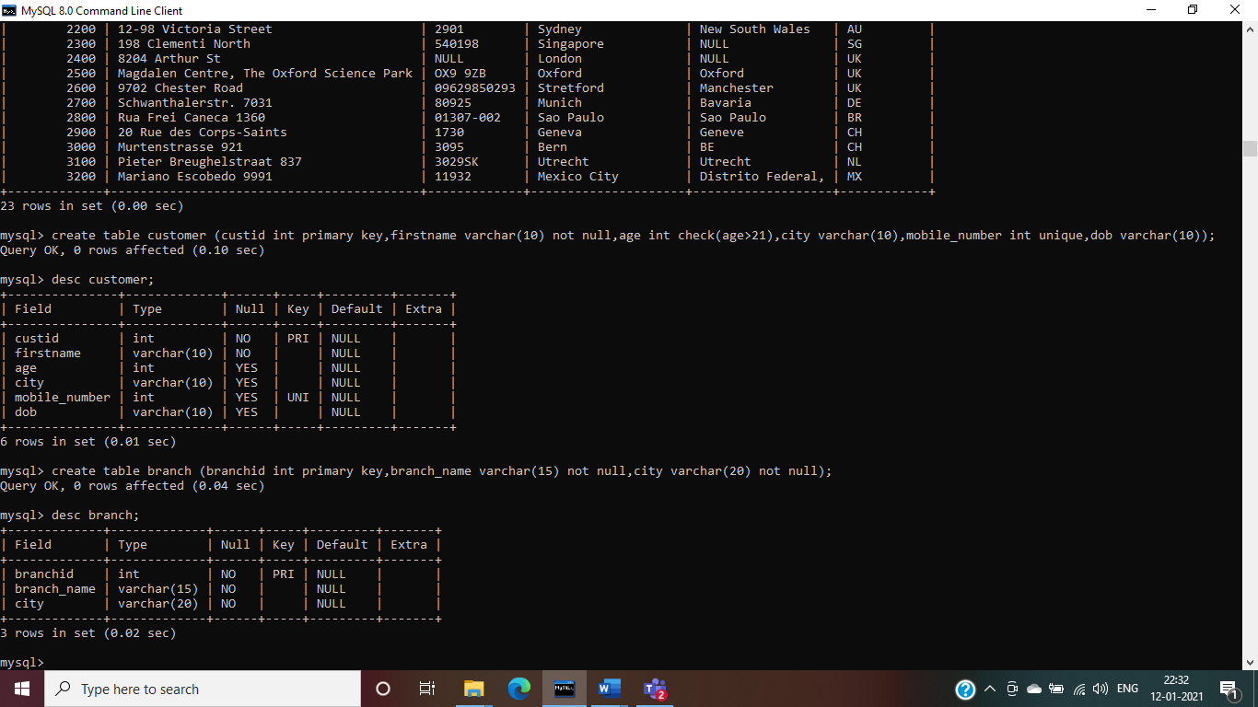

Table -----> Account

accountNumber, openingBalance, typeOfAccount, status,BankId,CustId

Add the Constraints

accountNumber is primary key

openingBalance must be greater than 5000

typeOfAccount must be saving/current

BankId is foreign key refer to BranchId(Primary key) Branch table

CustId is foreign key refer to Customer(Primary key) Customer table

Ans-

create table account (account_number int primary key,opening_balance int check(opening_balance>5000),type_of_account enum('savings','current'),branchid int,custid int);

alter table account add constraint b_fk foreign key(branchid) references branch(branchid);

alter table account add constraint c_fk foreign key(custid) references customer(custid);

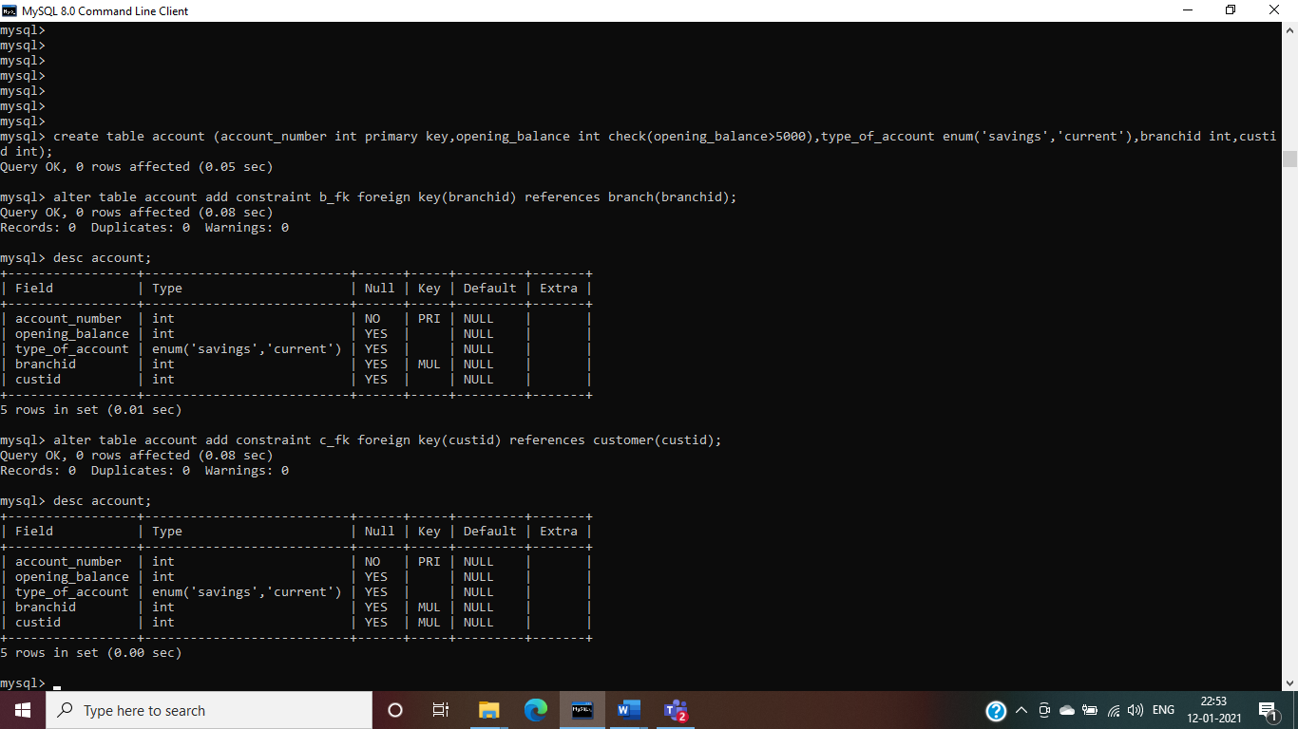

Table ----> Transaction

transactionId, transactionDate, MediumOfTransaction, TransactionAmount

Add the Constraints

transactionId is primary key

Ans-create table transaction (transaction_id int primary key,transaction_date varchar(10),medium_of_transaction varchar(10),transaction_amount float);

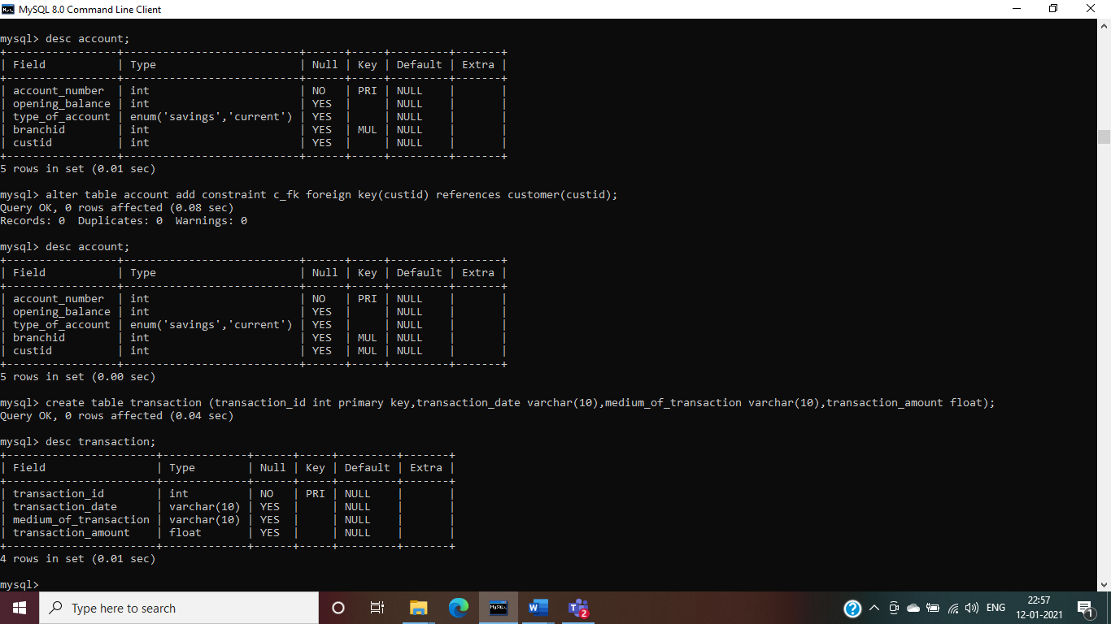

Table ----> Loan

LoanId, loanAmount, customerId and bankdId

Add the Constraints

loadId is primary key

loanAmount must be +ve

BankId is foreign key refer to BranchId(Primary key) Branch table

Ans-

create table loan (loanid int primary key,loan_amount float check(loan_amount>0.00),customer_id int,branch_id int);

alter table loan rename column branch_id to branchid;

alter table loan add constraint bl_fk foreign key(branchid) references branch(branchid);

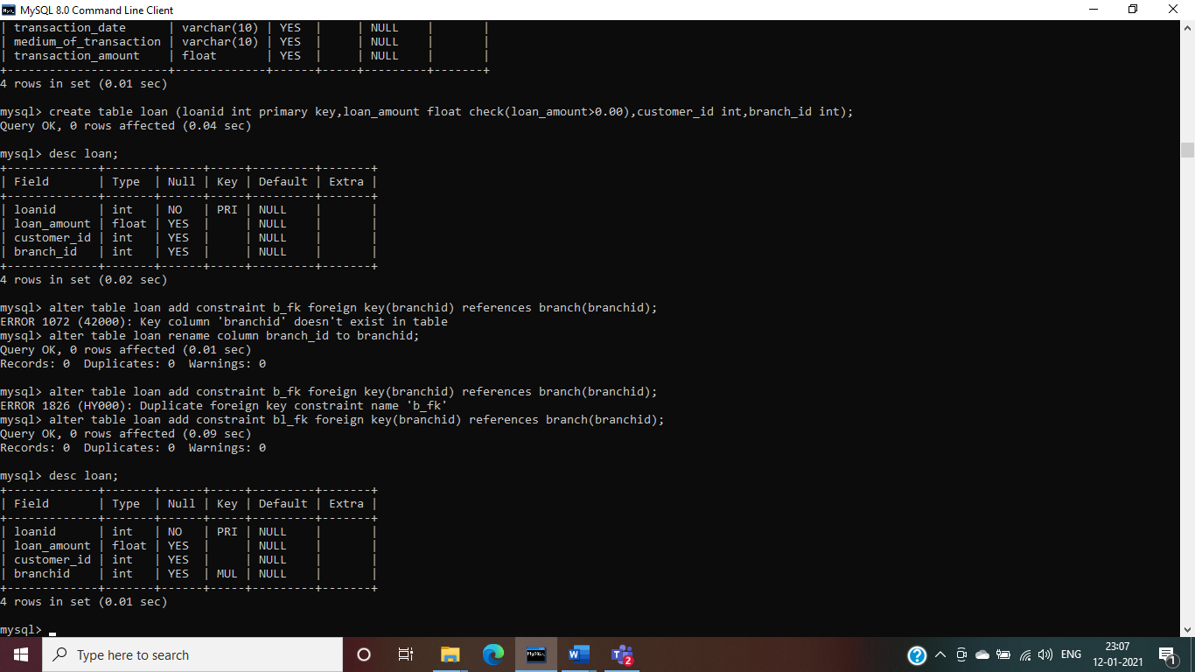

**Sub Query**

1. Display details of departments managed by ‘John’.

Ans- select * from departments where manager_id in (select employee_id from employees where first_name=’John’);

2. Display employees who did not do any job in the past.

Ans-select * from employees where employee_id not in (select employee_id from job_history);

3. Display job title and average salary for employees who did a job in the past.

Ans-select job_title ,avg(salary) from jobs natural join employees group by job_title where employee_id in (select employee_id from job_history);

4. Display country name, city, and number of departments where department has more than 5 employees.

Ans-select country_name,city, count(department_id) from countries join locations using (country_id) join departments using (location_id) where department_id in (select department_id from employees group by department_id having count(department_id)>5) group by country_name,city;

5. Display details of manager who manages more than 5 employees.

Ans-select first_name from employees where employee_id in (select manager_id from employees group by manager_id having count(*)>5);

6. Display details of current job for employees who worked as IT Programmers in the past.

Ans-select * from jobs where job_id in (select job_id from employees where employee_id in (select employee_id from job_history where job_id = ‘IT_PROG’));

7. Display the details of employees drawing the highest salary in the department.

Ans-select department_id , first_name,salary from employees outer where salary=(select max(salary) from employees where department_id = outer.department_id);

8. Display third highest salary of all employees

Ans- select salary from employees main where 2=(select count (distinct salary) from employees where salary> main.salary);